**Name**Sameer Khowaja

**Roll No**K17-3613

**Date of Submission**17 November 2020

<https://sameerkhowaja.github.io/Like_a_Boss_Website/MyWeb3/index.html>

**Web Pages**

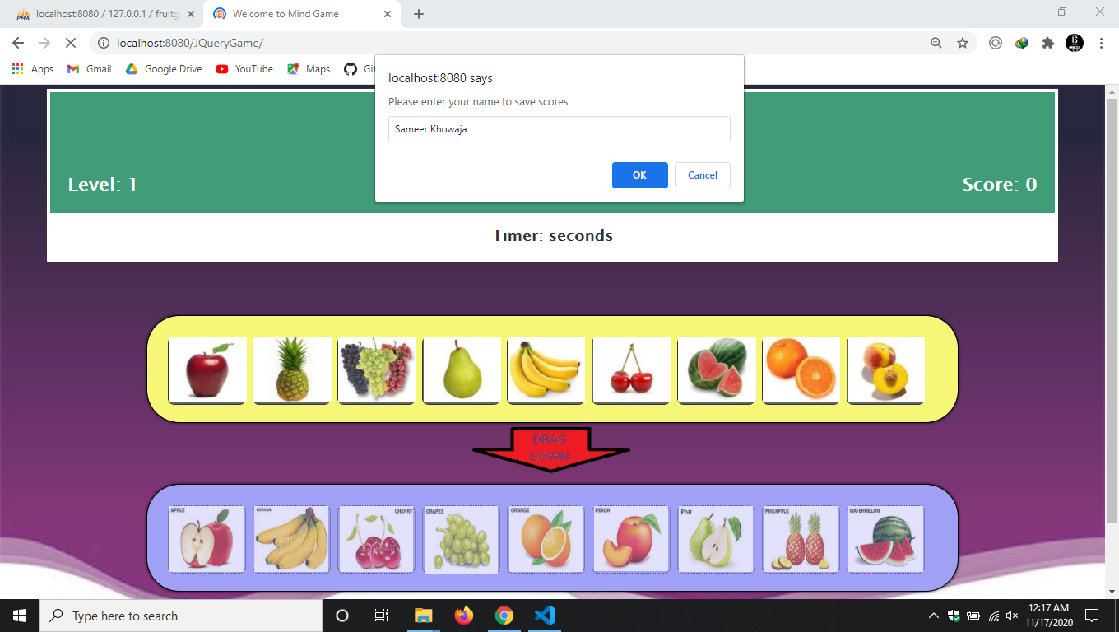

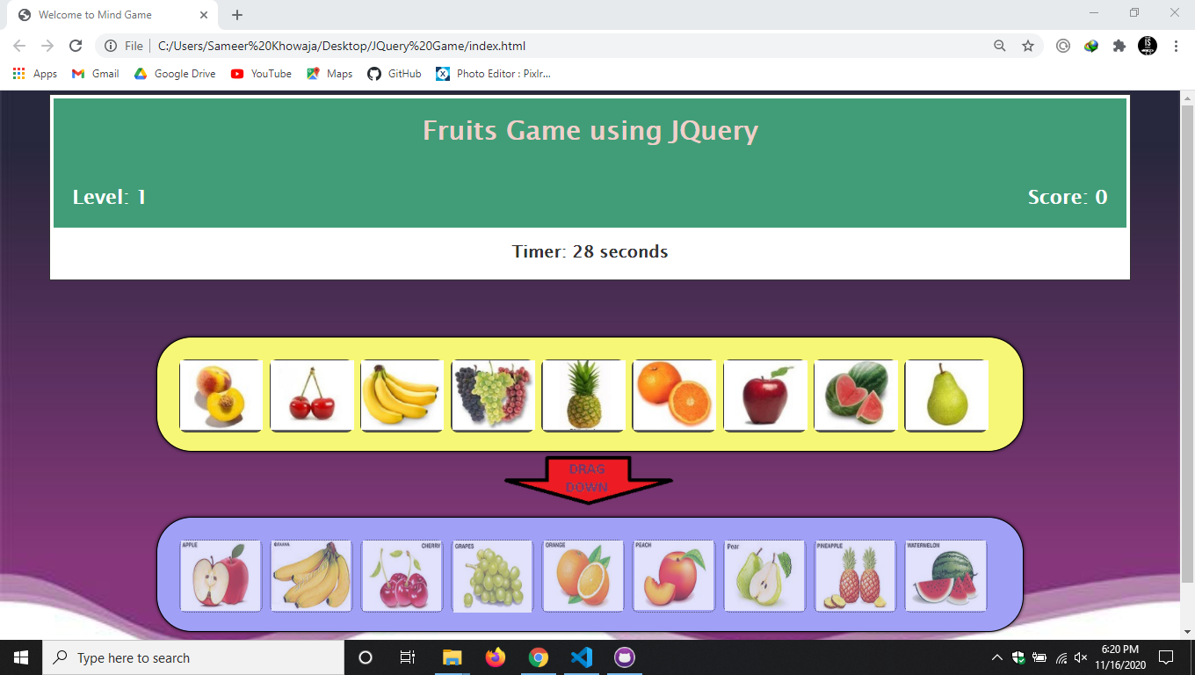

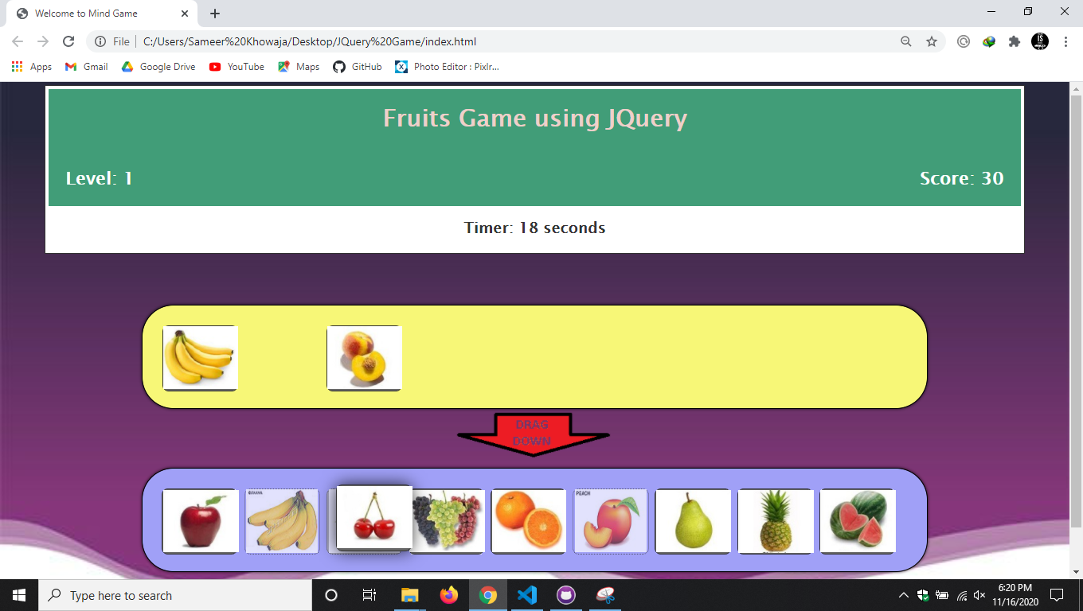

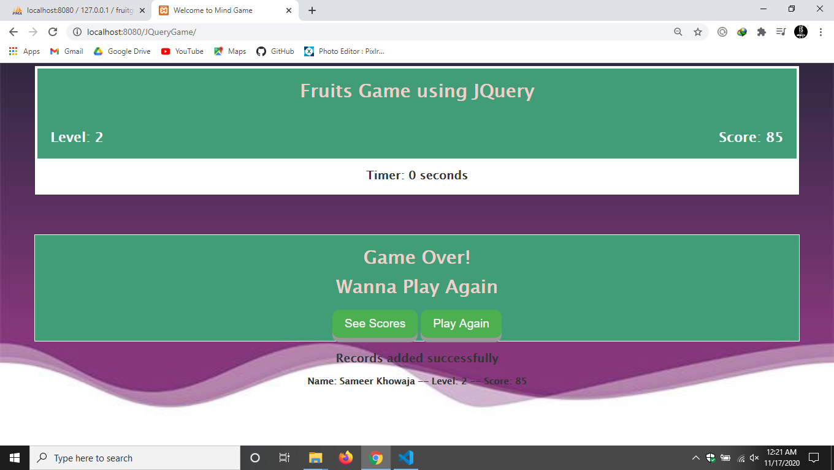

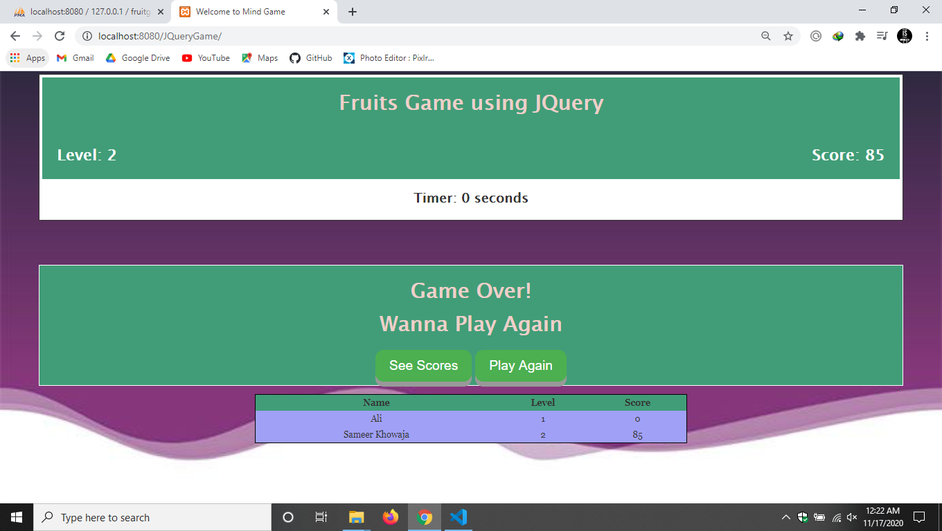

**SQL Tables**

